Assignment 2- Case Study

Stage 3 Lab Activities

SmartCare Domain Modelling
AI OFF -> AI ON -> COMPARE -> VERIFY | 1 hour

A - Requirements Review
Highlight nouns, verbs and business rules in SmartCare v0.2.
- The main nouns are : Patient, Practitioner, Appointment, date, time, duration, status, schedule, history, identifier, contact details, availability, report, search, filter, booking, cancellation, and no-show.

Thus, the strongest concepts are, (Patient, Practitioner, and Appointment ), as follows the rest are primarily attributes and values types,

Important verbs:
- Create patient, practitioner and appointment records.
- Update patient, practitioner and appointment information.
- Deactivate practitioners.
- Search for patients, practitioners and appointments.
- View patient information and appointment history.
- Book appointments.
- Reschedule appointments.
- Cancel appointments.
- Check for overlapping appointments.
- Prevent duplicate bookings.
- Change appointment status.
- Filter appointments.
- Generate basic appointment reports.
Business Rules:
- Each appointment must be associated with exactly one patient.
- Each appointment must be associated with exactly one practitioner.
- A patient may have zero or many appointments.
- A practitioner may have zero or many appointments.
- Two appointments for the same practitioner must not overlap.
- An appointment has a controlled status, such as Booked, Checked In, Completed, Cancelled or No-show.
- Appointment history must show relevant past and upcoming appointments.
- Patient, practitioner and appointment records must be searchable.
- Only confirmed requirements should determine the core domain model.
- Authentication, audit logging, notifications and complex scheduling remain provisional unless explicitly confirmed.

B - Candidate Classes
Record candidate concepts, supporting requirements, state and behaviour.
Candidate Concept | Supporting requirements | State | Behaviour | Decision
Patient | FR-01, FR-02, FR-07 | Patient ID, name, date of birth, contact details | Create, update, search and view patient information; access appointment history | Include
Practitioner | FR-03, FR-08 | Practitioner ID, name, role, availability, active/inactive state | Create, update, deactivate, search and view schedule | Include
Appointment | FR-04, FR-05, FR-06, FR-07, FR-08, FR-09 | Appointment ID, date, start time, duration, status | Book, update, reschedule, cancel, change status, detect overlap | Include
Status | FR-06 | A controlled appointment status value | Validate status values and transitions | Use as an enumeration/value type, not a class
Cancellation | FR-06 | Cancellation may include status, reason and timestamp | Cancel an appointment | Represent within Appointment unless detailed cancellation history is confirmed
Clinic | General SmartCare context only | Clinic name or location | Clinic-level management | Provisional; do not include in the core model
Database | Technical implementation concern | Stored data | Save and retrieve data | Reject as a domain class
UserAccount | FR-10, previously identified as provisional | Login credentials and role | Authenticate and authorize users | Provisional
AuditEntry | FR-11, previously identified as provisional | User, action, timestamp and record ID | Record and retrieve changes | Provisional
AppointmentReport | FR-12, previously identified as provisional | Date range and status counts | Generate appointment summaries | Provisional

C - CRC Cards
Create CRC cards for Patient, Practitioner and Appointment
Patient
Responsibilities | Collaborators
Store patient identification details | None
Store patient contact details | None
Support creation and updating of patient records | None
Support searching and viewing patient records | None
Provide the patient’s appointment history | Appointment
Validate required patient information | None

Practitioner
Responsibilities | Collaborators
Store practitioner identification details | None
Store professional role and availability | None
Support creation and updating of practitioner records | None
Support practitioner deactivation | Appointment
Provide the practitioner’s schedule and history | Appointment
Help determine whether a time is available | Appointment

Appointment
Responsibilities | Collaborators
Store appointment date, time and duration | Patient, Practitioner
Store the current appointment status | None
Link one patient to one practitioner | Patient, Practitioner
Create and update bookings | Patient, Practitioner
Reschedule or cancel an appointment | Patient, Practitioner
Validate status changes | None

D - UML Model
Draw classes, attributes, operations, associations and multiplicities.
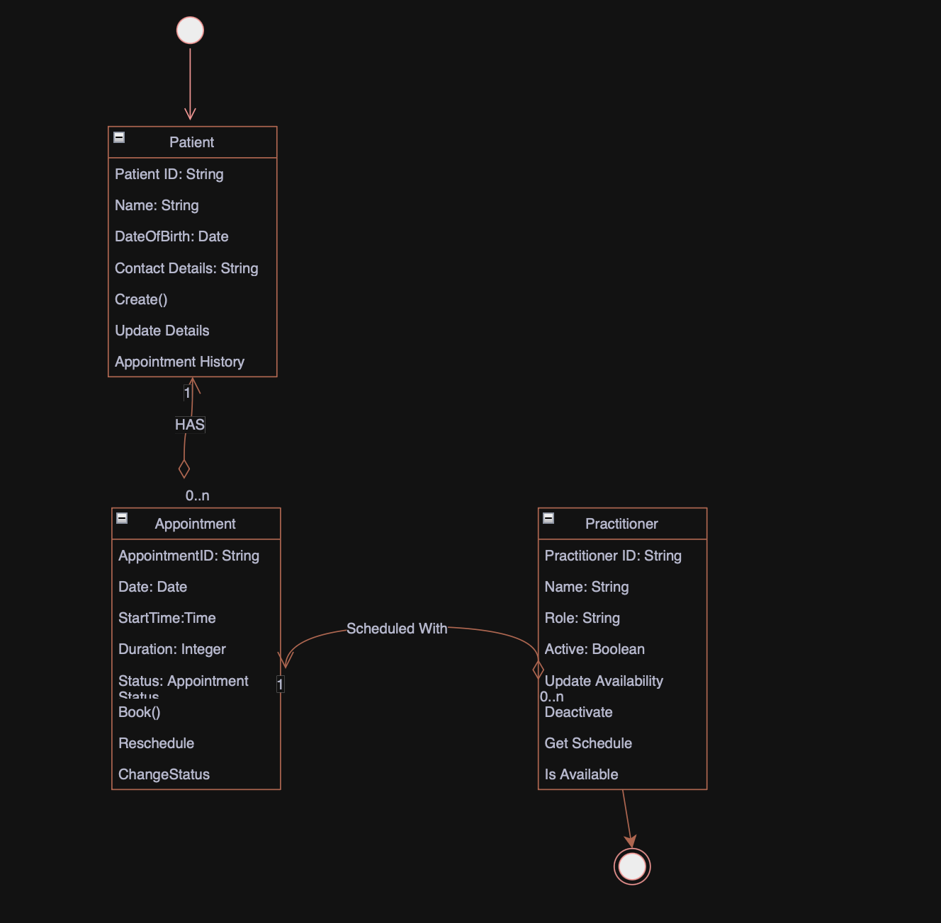

E - AI Design Review
Ask AI to suggest classes and relationships using only confirmed requirements; require supporting requirement IDs.
AI suggestion | Supporting requirement IDs | Proposed relationship | Initial assessment
Patient | FR-01, FR-02, FR-07 | Patient 1 to Appointment 0 | Strongly supported; include
Practitioner | FR-03, FR-08 | Practitioner 1 to Appointment 0 | Strongly supported; include
Appointment | FR-04, FR-05, FR-06, FR-07, FR-08, FR-09 | Each appointment references one patient and one practitioner | trongly supported; include
Appointment Status | FR-06 | Appointment has one controlled status value | Supported as an enumeration/value type, not a full class
Schedule Engine | FR-05 | Checks practitioner appointment overlap | Partly supported, but may be excessive for the initial system
Patient Manager | FR-01, FR-02, FR-07 | Manages patient operations | Possible service-layer component, not a core domain class
Practitioner Manager | FR-03, FR-08 | Manages practitioner operations | Possible service-layer component, not a core domain class
Appointment Manager | FR-04, FR-05, FR-06, FR-09 | Coordinates appointment workflows | Possible application service, not a core domain entity
Notification Manager | No confirmed requirement | Sends email or SMS reminders | Unsupported; reject
Clinic | No specific confirmed requirement | Owns patients, practitioners and appointments | Unsupported for the current single-clinic model; defer
Database | No business requirement | Stores all objects | Technical concern; exclude from domain model

F - Compare and Decide
Record at least one accepted, modified and rejected AI suggestion.
AI suggestion | Evidence | Decision | Reason | Model change
Appointment as a central class linking Patient and Practitioner | FR-04, FR-05, FR-06, FR-07, FR-08 and FR-09 all refer directly to appointment data or behaviour. | Accepted | It is directly supported by several confirmed requirements and resolves the relationship between patients and practitioners. | Include Appointment with two one-to-many associations.
Schedule Engine for duplicate-booking prevention | FR-05 confirms that overlapping bookings must be prevented, but it does not confirm recurring schedules, rooms, optimization or complex availability rules. | Modified | A full engine would be over-design for the current scope. | Use an overlaps() operation or a small scheduling service initially; defer Schedule Engine.
Notification Manager for appointment reminders | No confirmed requirement specifies SMS, email or other notifications | Rejected | It introduces an unconfirmed feature and external integration complexity. | Do not include it in the current model.

G - Python Skeletons
Create simple Patient, Practitioner and Appointment class skeletons.
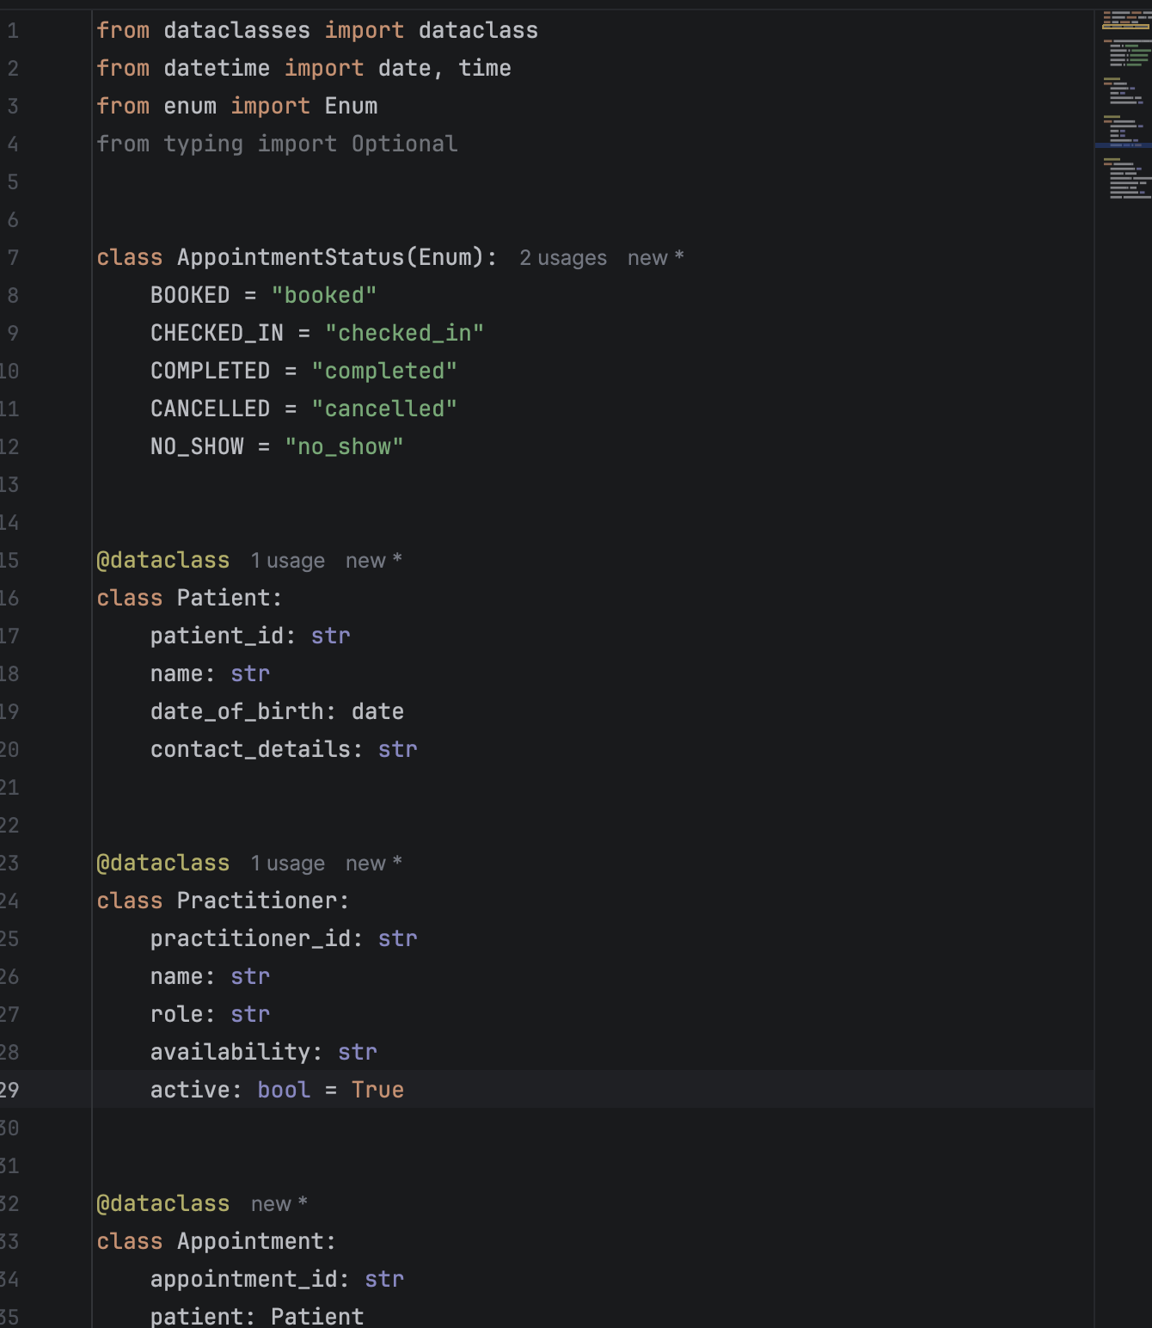

H - Consistency Check
Check model-code consistency; do not implement full behaviour yet.
UML element | Python element | Consistent? | Notes
Patient Id | Patient_id | Yes | Naming convention changes from UML camelCase to Python snake_case only.
Patient.name | Patient.name | Yes | Represented directly.
Patient.dateOfBirth | Patient.date_of_birth | Yes | Same concept, Python naming convention applied
Patient.contactDetails | Patient.contact_details | Yes | Represented directly.
Practitioner.practitionerId | Practitioner.practitioner_id | Yes | Represented directly.
Practitioner.name | Practitioner.name | Yes | Represented directly.
Practitioner.role | Practitioner.role | Yes | Represented directly

Reflection
What modelling decision was hardest? Where did AI over-design? What evidence supported your final choices?

The hardest modelling decision was whether duplicate-booking prevention required a separate Schedule Engine class. The confirmed requirement clearly requires overlap prevention, but it does not require recurring schedules, rooms, resource allocation or optimisation. The evidence therefore supports a simpler Appointment. Overlaps, operation or small scheduling service rather than a full engine.
AI over-designed the solution by proposing Notification Manager, Clinic Controller, several manager classes and a full Schedule Engine without confirmed requirements supporting those abstractions. These classes may be useful in a larger future system, but they would add complexity to the current model.
The final choices were supported by the confirmed requirement IDs:
- Patient by FR-01, FR-02 and FR-07.
- Practitioner by FR-03 and FR-08.
- Appointment by FR-04 through FR-09.
- Duplicate-prevention behaviour by FR-05.
- Status representation by FR-06.
The decision not to include notifications, a database class or a clinic ownership hierarchy was supported by the absence of confirmed requirements for those features.

